
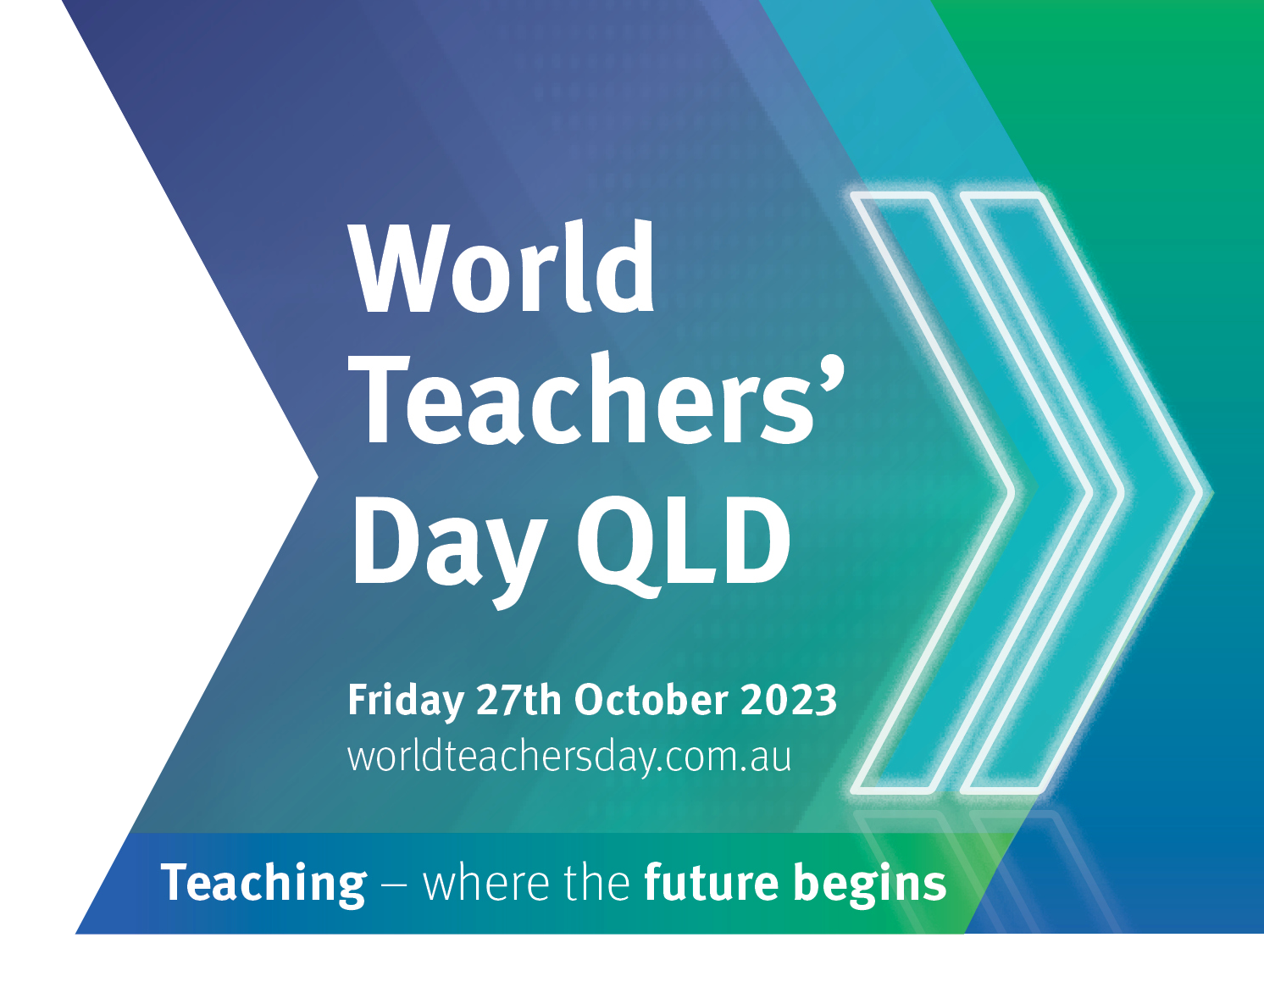
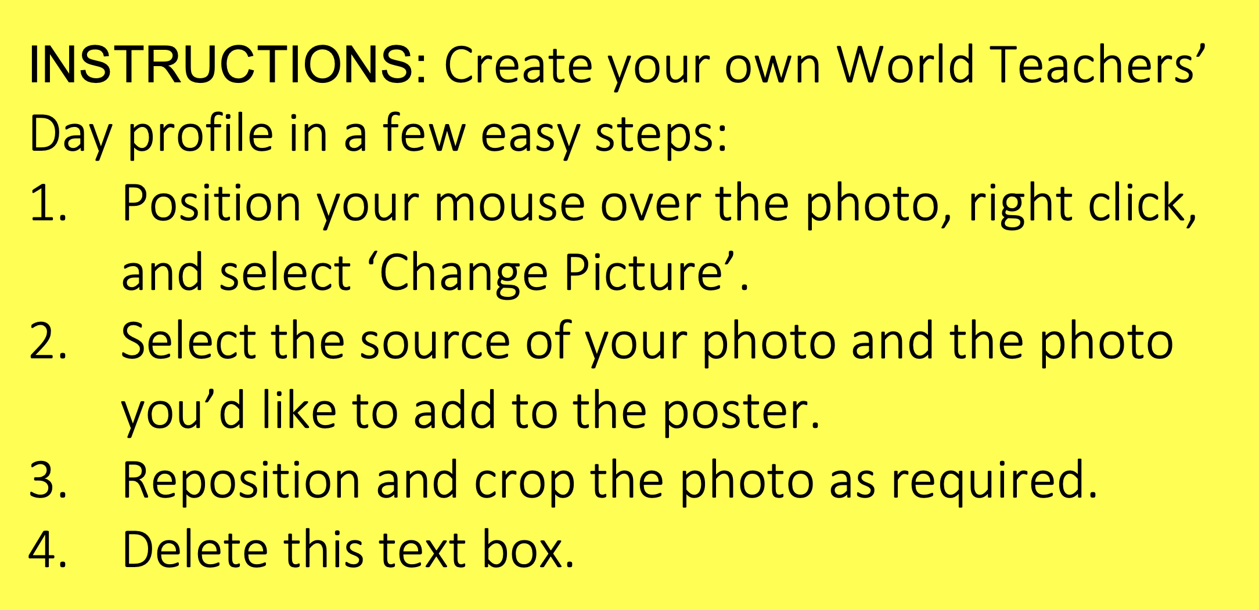

Heading 1

Heading 2
Formatting text is straight forward in departmental templates when you use the style palettes that have been provided. The MSWord style palettes are set inArial, one of the Queensland Government corporate identity fonts.
The style palettes are set with the optimum font size, line length, column width and paragraph spacing for best readability. No other fonts can be used in documents, publications, video and PowerPoint presentations.

Heading 3
Formatting text is straight forward in departmental templates when you use the style palettes that have been provided. The MSWord style palettes are set in Arial, one of the Queensland Government corporate identity fonts.
The style palettes are set with the optimum font size, line length, column width and paragraph spacing for best readability. No other fonts can be used in documents, publications, video and PowerPoint presentations.

Heading style 4
Formatting text is straight forward in departmental templates when you use the style palettes that have been provided. The MSWord style palettes are set in Arial, one of the Queensland Government corporate identity fonts.
The style palettes are set with the optimum font size, line length, column width and paragraph spacing for best readability. No other fonts can be used in documents, publications, video and PowerPoint presentations.

Heading 2
Formatting text is straight forward in departmental templates when you use the style palettes that have been provided. The MSWord style palettes are set in Arial, one of the Queensland Government corporate identity fonts.
The style palettes are set with the optimum font size, line length, column width and paragraph spacing for best readability. No other fonts can be used in documents, publications, video and PowerPoint presentations.

Heading 3
Formatting text is straight forward in departmental templates when you use the style palettes that have been provided. The MSWord style palettes are set in Arial, one of the Queensland Government corporate identity fonts.
The style palettes are set with the optimum font size, line length, column width and paragraph spacing for best readability. No other fonts can be used in documents, publications, video and PowerPoint presentations.

Heading style 4
Formatting text is straight forward in departmental templates when you use the style palettes that have been provided. The MSWord style palettes are set in Arial, one of the Queensland Government corporate identity fonts.
The style palettes are set with the optimum font size, line length, column width and paragraph spacing for best readability. No other fonts can be used in documents, publications, video and PowerPoint presentations.

